Individual Assignment III: PL/SQL GOTO Statements and Functions
THOSE ARE THE PARTS WITH THEIR SCREENSHOTS.

PART A: GOTO
A1: NUMBER CLASSIFIER

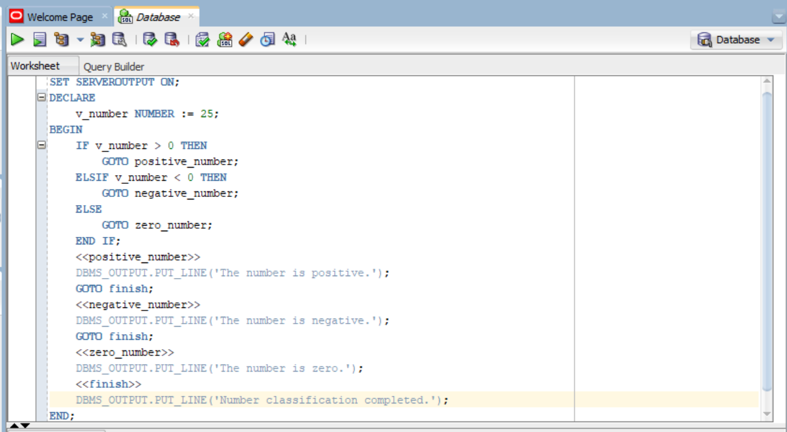
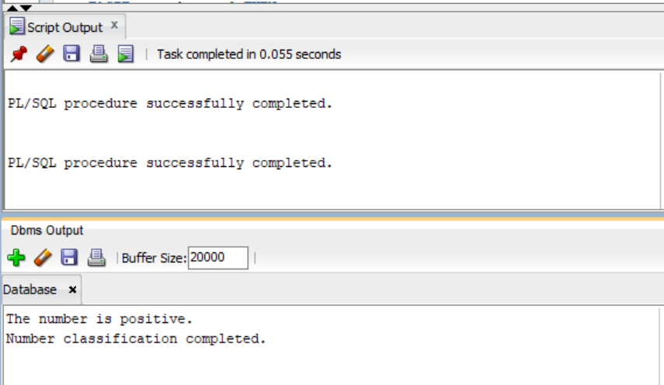
A2: SALARY REVIEW
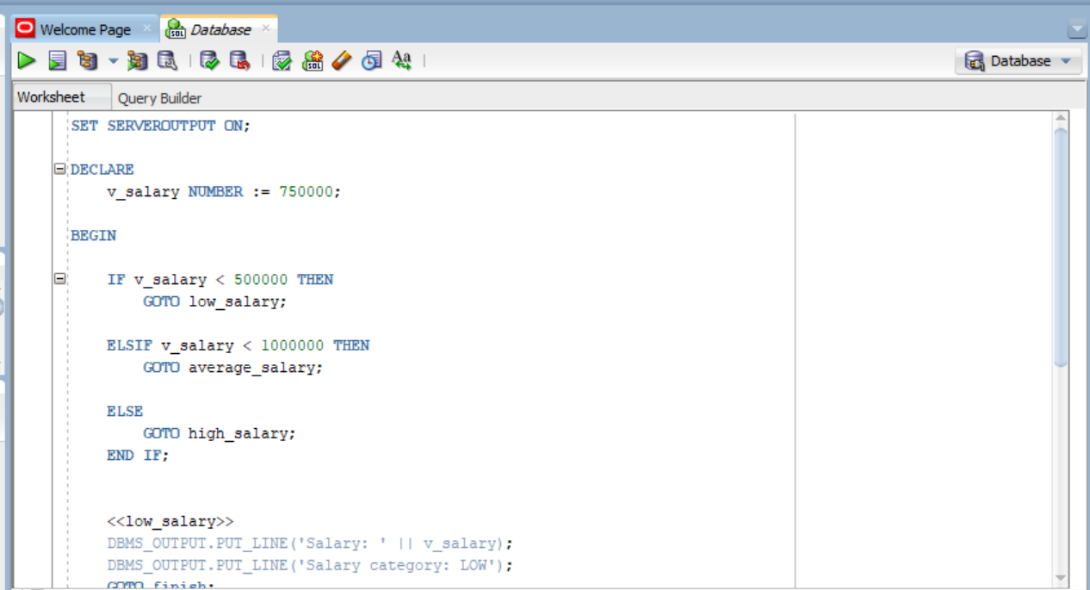
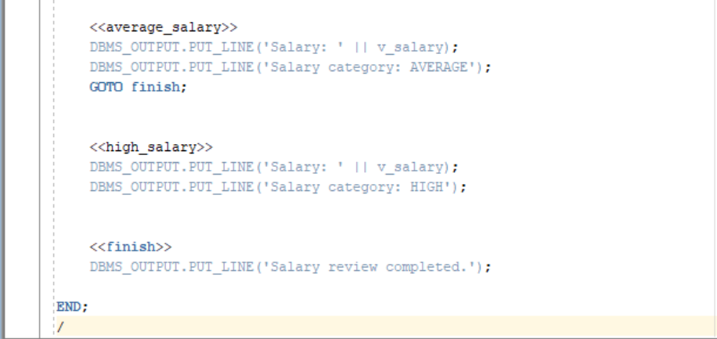
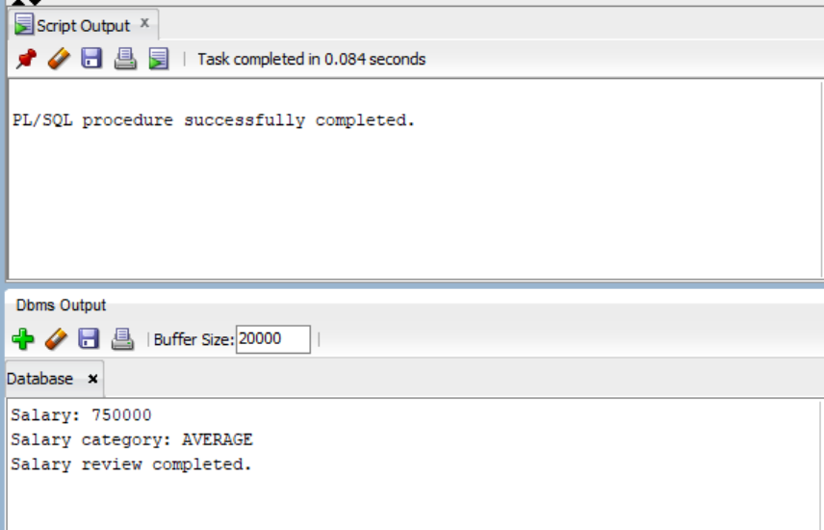
A3:WRITTING ILLEGAL GOTO AND FIX

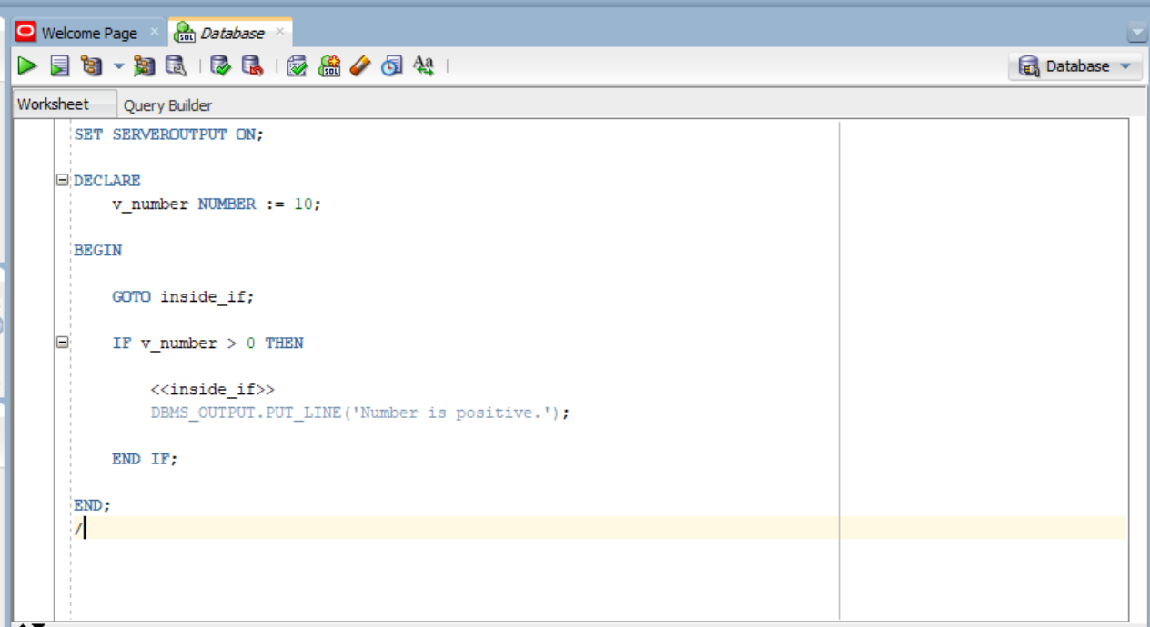

ERROR INDICATED:
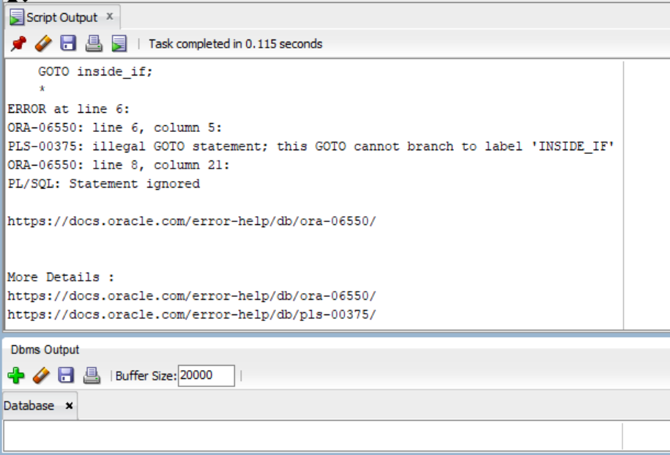
HOW TO SOLVE IT?
Instead of jumping into the IF, we put the GOTO and label in a valid location.
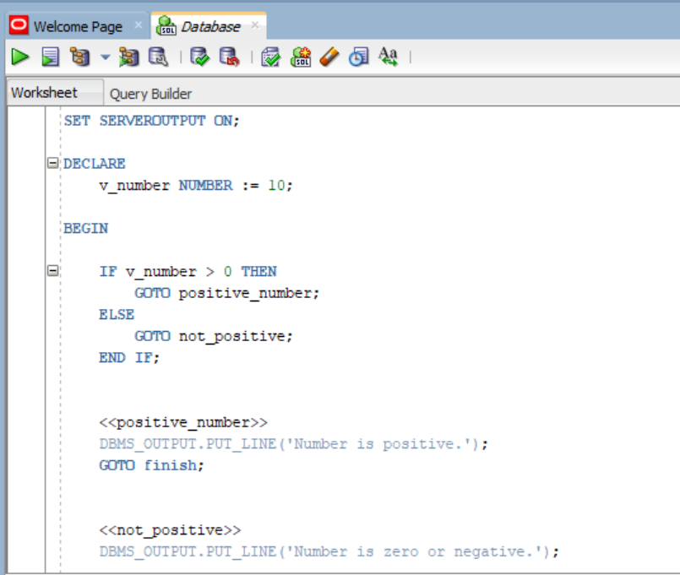
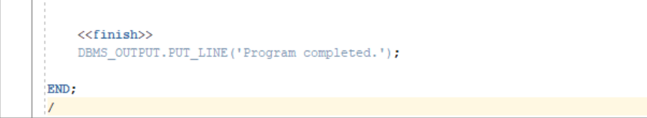
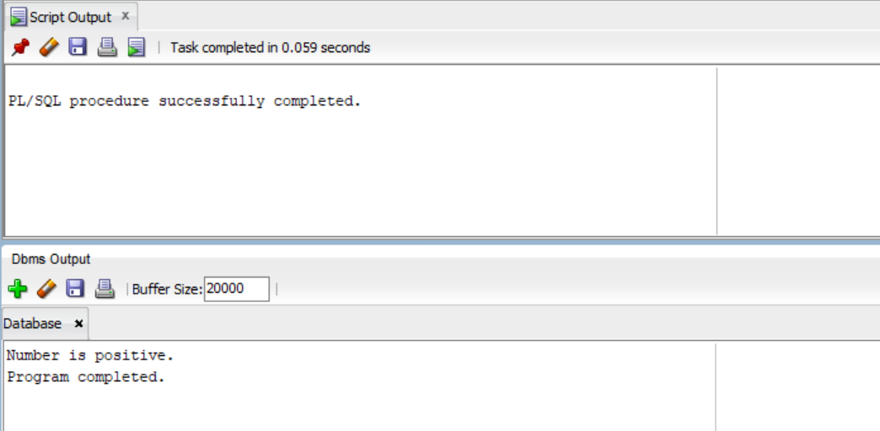
A4: REWRITTING WITHOUT GOTO
From Example inside A2, we are going to rewrite it without a GOTO.
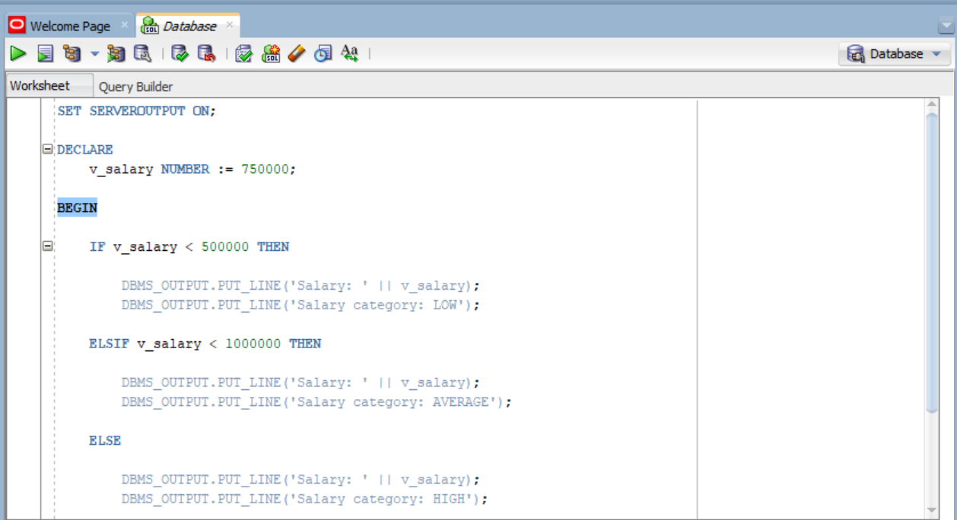
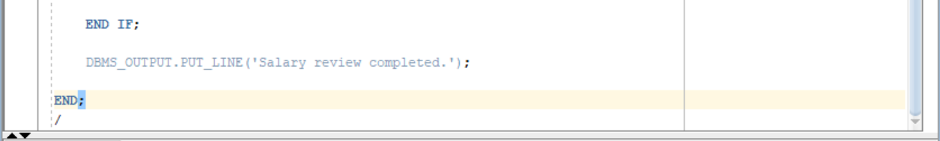
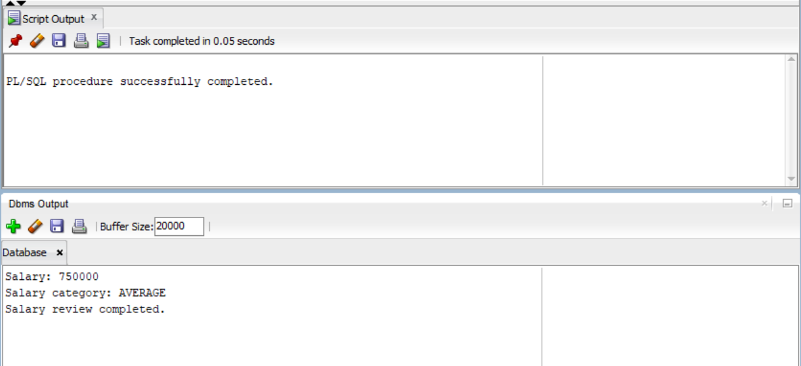

PART B: FUNCTIONS
B1: Annual Salary Function
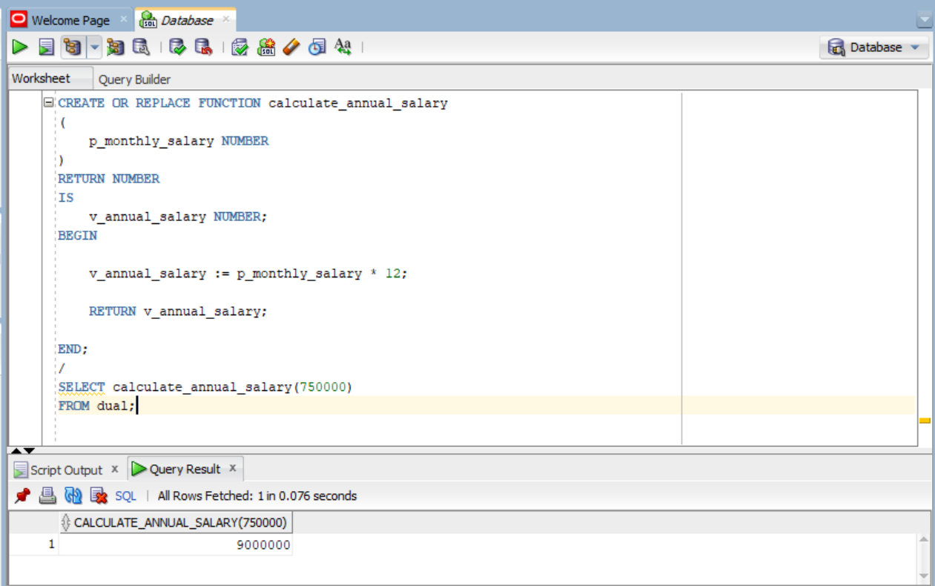

B2: Years of Service
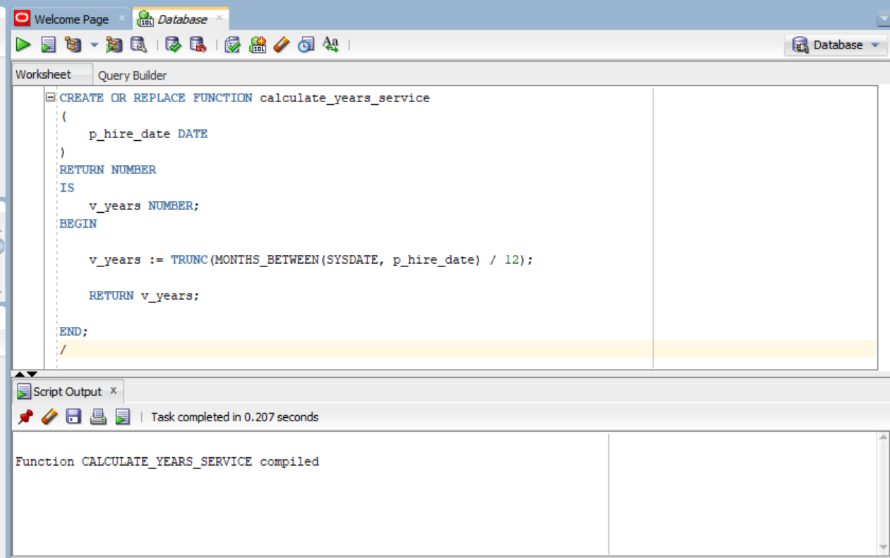

B3: TAX CALCULATOR
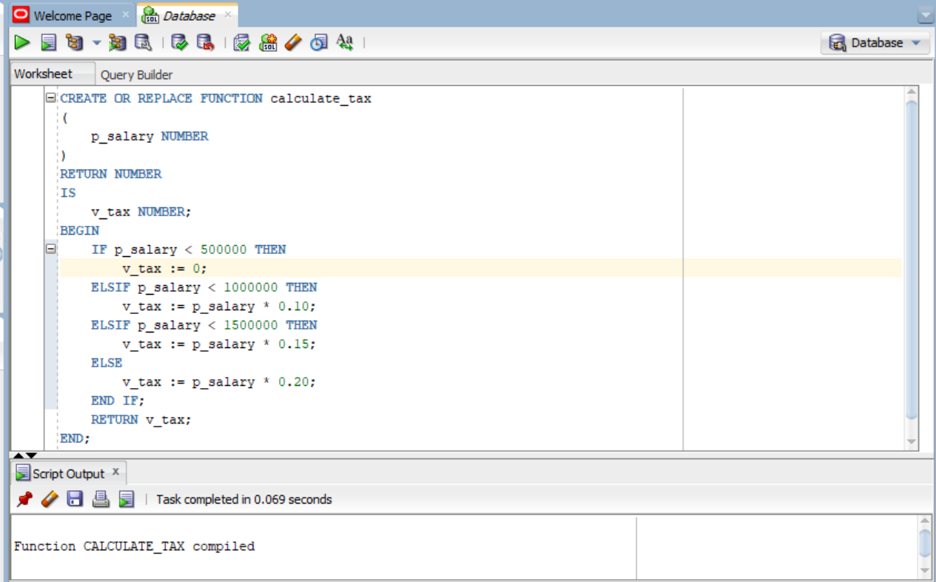
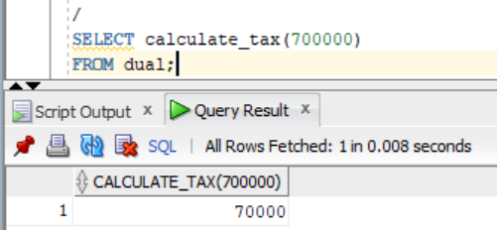

B4: DEPARTMENT NAME
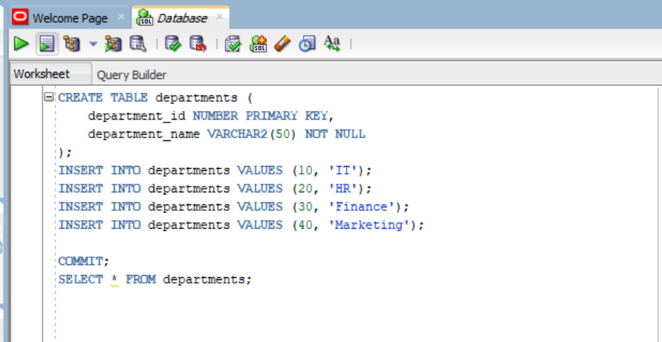
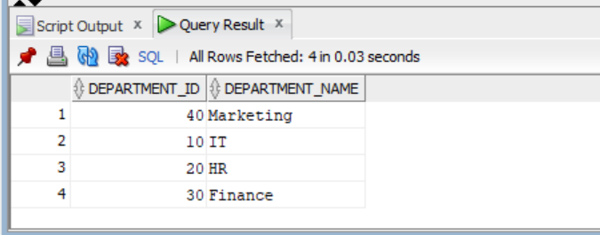
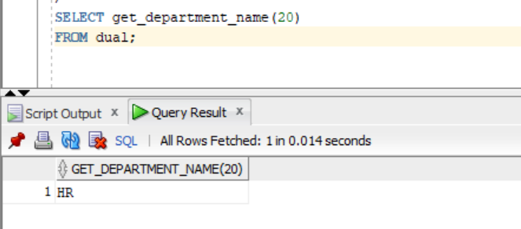
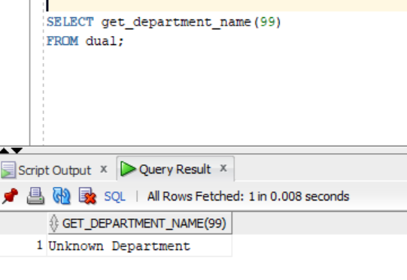
B5: FUNCTIONS IN SQL
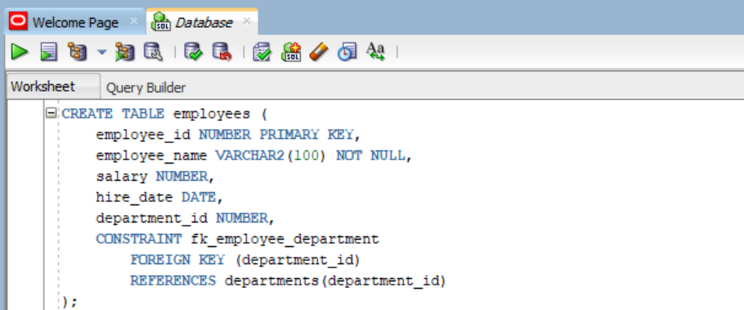
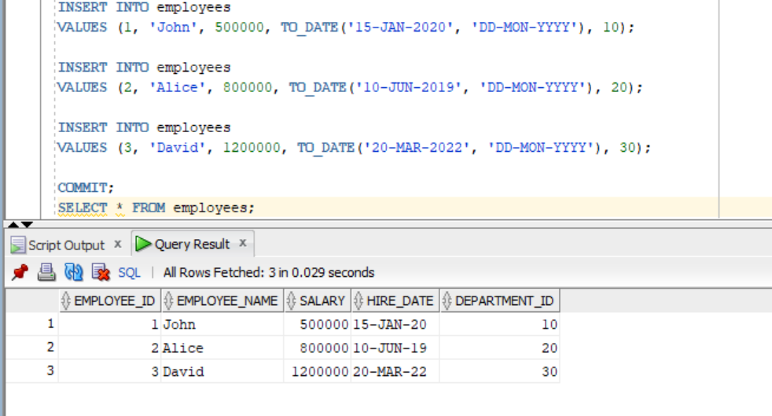
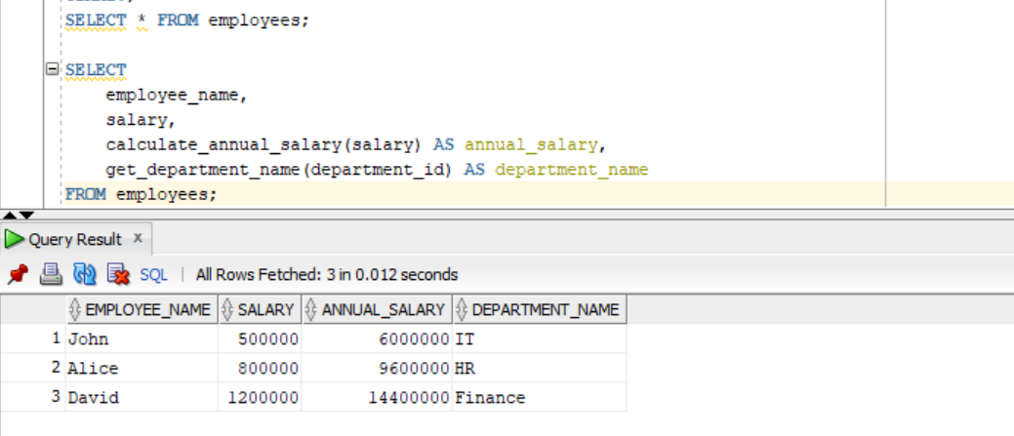
PART C: COMBINED TASKS
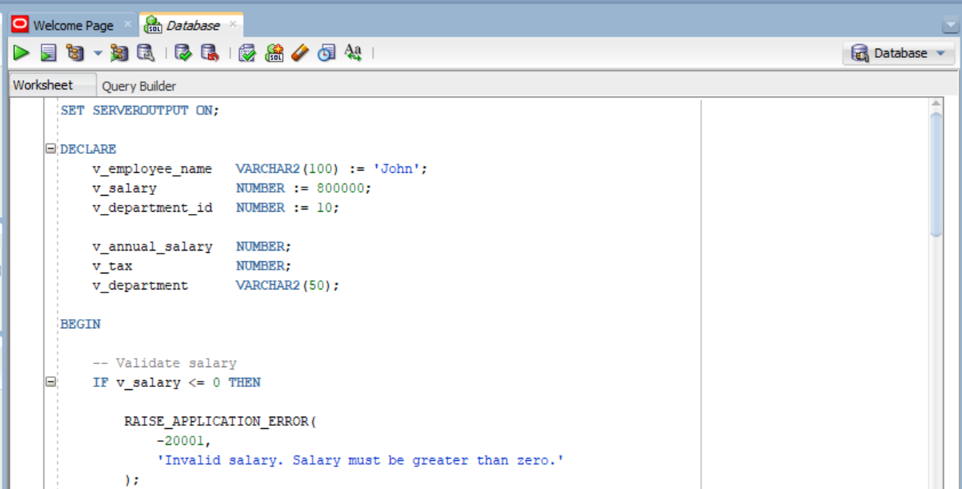
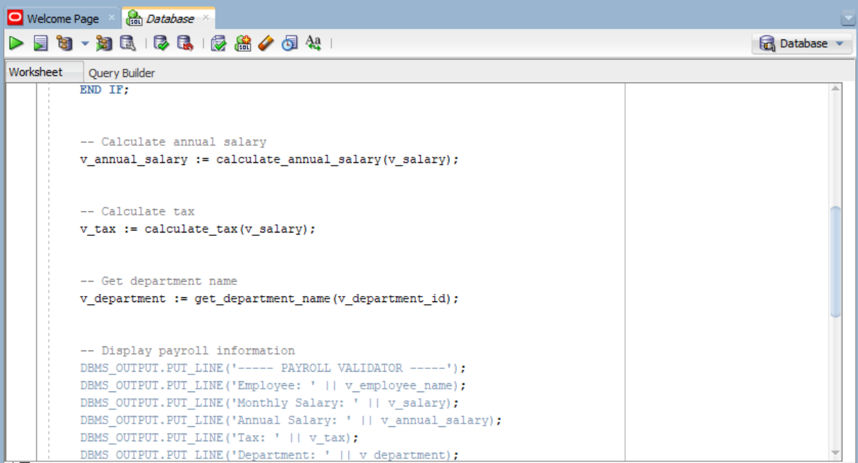
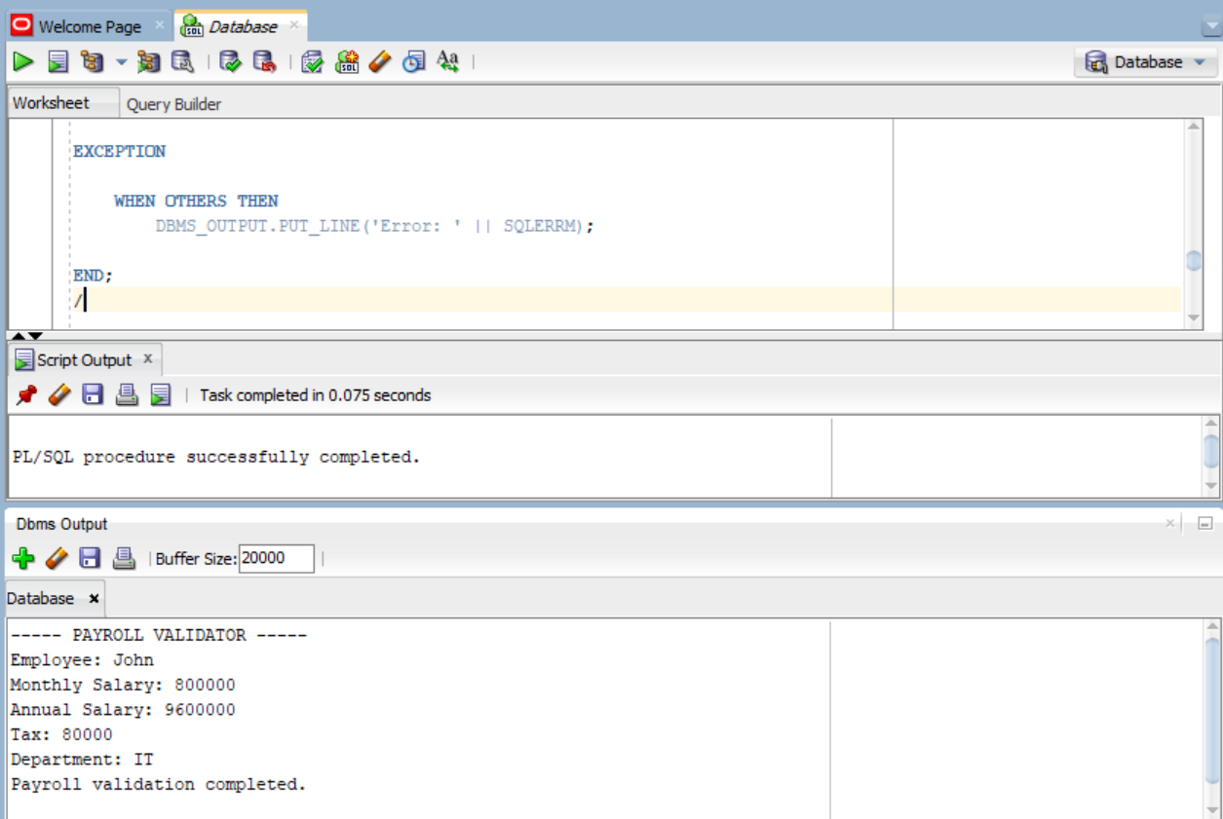

AI Usage
I used AI to understand the assignment, explain PL/SQL concepts, help write and debug codes that I could not write by Myself. I then tested the code myself in Oracle SQL Developer and verified the results.

